WEEK 6
Step 1: Mark Inside & Outside Interfaces
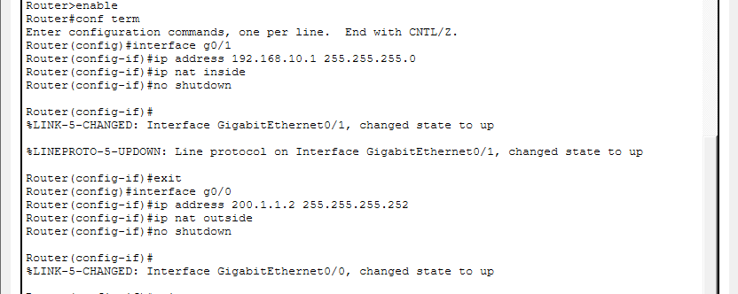
Step 2: Create Access List for Internal Network
Step 3: Enable NAT Overload (PAT)
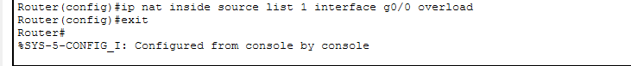
Verification
Show ip nat translations
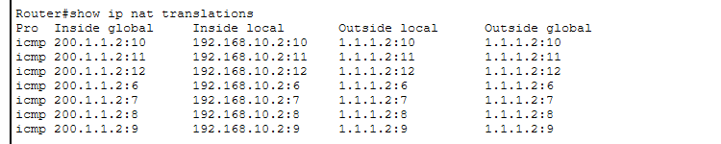
Show ip nat statistics
